H.T No
Regulations:
A20

Sreenidhi Institute of Science and Technology
(An Autonomous Institution)
Code No:8B730 Date: 14-June-2024 (FN)

B.Tech IV-Year I-Semester End External Examination, June - 2024 (Supplementary)
FINITE ELEMENT METHODS(ME)

Time: 3 Hours Max.Marks:70

Note: a) No additional answer sheets will be provided.
b) All sub-parts of a question must be answered at one place only, otherwise it will not be valued.
c) Missing data can be assumed suitably.

Bloom's Cognitive Levels of Learning (BCLL)

Remember | L1 | Apply | L3 | Evaluate | L5
Understand | L2 | Analyze | L4 | Create | L6

Part - A Max.Marks:20
Answer all QUESTIONS

 |  | BCLL | CO(s) | Marks
1 | What is a plane stress problem and give an example? | L1 | CO1 | [2M]
2 | What is the transformation matrix for a truss element between local and global coordinates? | L1 | CO2 | [2M]
3 | What is the equivalent load vector of uniformly distributed load on a beam element? | L1 | CO3 | [2M]
4 | State the reasons for calling three noded triangular element as CST and 6 noded triangular element as LST? | L2 | CO4 | [2M]
5 | What do you mean by steady state heat transfer analysis? | L2 | CO5 | [2M]
6 | What is Hamilton’s principle | L1 | CO6 | [2M]
7 | What are the reasons for selecting polynomial equations for interpolation function? | L2 | CO2 | [2M]
8 | Write the element stiffness matrix for the beam element | L1 | CO3 | [2M]
9 | What is dynamic analysis | L2 | CO6 | [2M]
10 | Name the methods to apply boundary conditions. | L1 | CO1 | [2M]
Part – B Max.Marks:50
ANSWER ANY FIVE QUESTIONS. EACH QUESTION CARRIES 10 MARKS.

 |  |  | BCLL | CO(s) | Marks
11. |  | Derive material property matrix for 3D and 2D problems | L2 | CO1 | [10M]
12. |  | A load P = 60 kN is applied as shown. Determine the displacement field, stress, and support reactions in the body. Take E = 20x10³ N/mm².  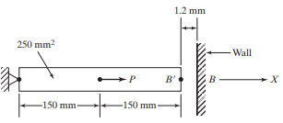 | L4 | CO2 | [10M]
13. |  | Derive Hermite shape functions of a beam element and represent graphically. | L3 | CO3 | [10M]
14. |  | Calculate displacements and stress in a triangular plate shown below, fixed along one edge and subjected to concentrated load at its free end. Assume E = 70,000 MPa, t = 10 mm and ʋ = 0.3.  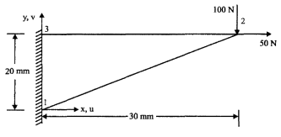 | L3 | CO4 | [10M]
15. |  | Consider a brick wall of thickness L = 30 cm, k = 0.7 W/m K. The inner surface is at 28⁰C, and the outer surface is exposed to cold air at −15⁰C. The heat-transfer coefficient associated with the outside surface is h = 40 W/m²K. Determine the steady state temperature distribution within the wall and also the heat flux through the wall. Use a two-element model. | L3 | CO5 | [10M]
16. |  | Determine the eigenvalues for the stepped bar. Take E=200GPa and density=7000Kg/m³  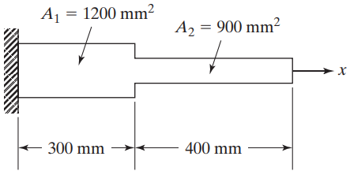 | L4 | CO6 | [10M]
17. | a) | Derive strain displacement relations for 2D element. | L2 | CO1 | [4M]
 | b) | Derive the quadratic shape functions of a bar element | L2 | CO2 | [3M]
 | c) | Derive potential energy equation for a beam element for different loading. | L2 | CO3 | [3M]
18. | a) | Explain about shape functions of CST element? | L2 | CO4 | [4M]
 | b) | Derive the 1-D steady state heat conduction equation for FEM | L2 | CO5 | [3M]
 | c) | Derive element mass matrix for bar element | L2 | CO6 | [3M]
-- 00 -- 00 –

